ZoomCamp Week1 – Docker & Terraform

Question1:



--rm

Question2:

0.42.0

Question3:

15612

Question4:

2019-09-26

Question5:

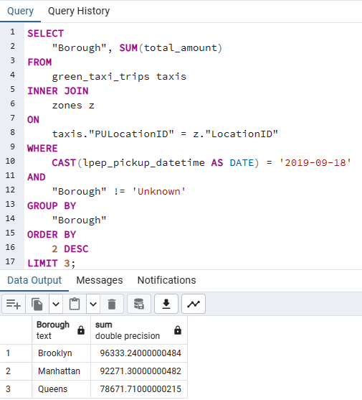

Brooklyn Manhattan Queens

Question6:

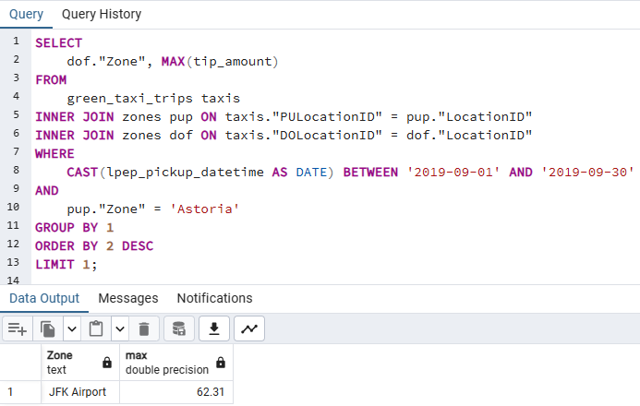

JFK Airport